Intelligent Vehicle Mounted Thermal Imaging Night Vision System

User Manual

CONTENT

INTRODUCTION 1
WELCOME 3
PRECAUTIONS 5
DISCLAIMER 7
CHARACTERISTICS 8
COMPONENTS 9
PRODUCT LIST 10
ISTALLATION 12
EARLY ALARM 24
UPGRADE 25
MAIN PARAMETERS 26
PRODUCT INTERFACE DEFINITIION 28
AFTER-SALE SERVICE 30

INTRODUCTION
In recent years, with the rapid development of artificial intelligence and autonomous driving technology, numerous systems for driver driving assistance have emerged in the market, and various innovative technologies can improve the comfort and safety of drivers while not interfering with their operations.
The core function of many driver assistance systems is to warn drivers of possible hazards in advance, thus avoiding traffic accidents.
Without the Night Vision System, for drivers driving at night, if encounter poor lighting, the drivers on the opposite lane using high beam, or bad weather like rain, fog and haze, there is no way to clearly see the distant pedestrians. At this time, it is exceedingly easy for vulnerable traffic participants (pedestrians, bicycles, motorcycles, electric vehicles, tricycles, etc.) to collide and cause irreparable damage. In this case, if the car is equipped with our Night Vision System of which the thermal imaging camera can capture the far-infrared heat radiation emitted by pedestrians and other vulnerable traffic participants, and which then forms a video image by the intensity of the heat radiation, drivers’ view range will be greatly improved. As the Night Vision System is also equipped with advanced pedestrian recognition, it has the ability to provide advance warning, enabling drivers to easily deal with complex road conditions at night and drive safely to avoid dangerous situations.

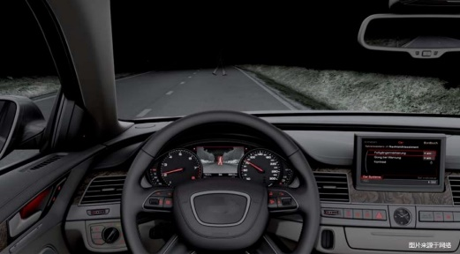
The picture above shows that after using the "night vision system", the driver can see the originally invisible pedestrian and road information clearly displayed on the screen, and the pedestrian is shown red, indicating the possibility of collision hazards. Also, the system can make a sound alert, so that the driver has sufficient time to deal with such hazards to reduce night traffic accidents.

WELCOME
Thank you very much for choosing our Night Vision System for automobiles.
This assisted driving product uses advanced stabilization technology, sensor technology, image processing technology and efficient multi-threaded deep learning artificial intelligence recognition algorithm, to match the demand of the automotive aftermarket and the need of driving at night and in bad weather conditions. the product uses non-cooling infrared detector and low-power high-performance artificial intelligence SOC. The imaging of the product has features of lightless imaging, anti-glare, penetrating smoke, fog, haze, with functions of intelligent pedestrian detection, anti-collision alarm, which can greatly improve the driver's night driving safety.
Before installing and using this product, please read in detail and keep this manual . Hope this product can meet your needs and serve you for a long time!
The Company reserves the right of final interpretation of the inconsistency of the manual with some functions and operations due to software and hardware upgrades.
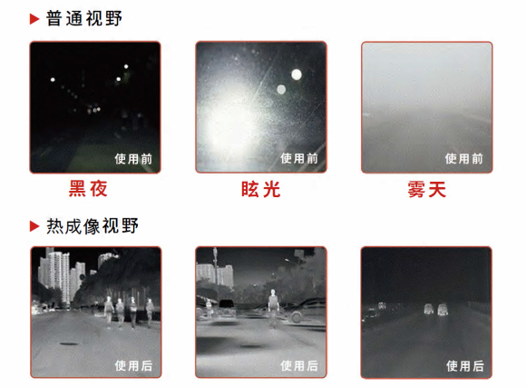

PRECAUTIONS
- Thermal imaging technology is widely used in military, aerospace and other fields. The productis only suitable for civil driving assistanc. Please comply with the relevant laws of your country and do not use it for any illegal purposes.
- Please use the product in -30~70 degrees Celsius.
- The camera is IP67 waterproof while the controller is not .
- Please do not touch the camera lens directly with your hands when the lens needs to be cleaned to prevent the acid left by your fingers to damage the increased transmission film coated to improve the quality of imaging. Please use a special lens cloth or glasses cloth to wipe.
- Please do not direct the lens to the sun, large lasers, welding machines and other ultra-strong light sources for a long time, so as not to damage the precision optical devices.
- It is normal to have different imaging quality in different temperature as thermal imaging images through the object surface temperature difference. As the ambient temperature increases, the contrast of the thermal imaging video is reduced, it will make the temperature difference between the person and the environment get smaller.
- It is normal that the image has a short time lag (about 150ms) and then returns to normal as a result of the adoption of automatic shutter refresh technology to ensure continuous acquisition of high quality images.
- Please go to the designated repair point as soon as possible to when the protection window is broken due to excessive external impact for the internal components in the high-strength protection window is designed to automatically heat up in low-temperature environments to defrost and melt ice.

DISCLAIMER
- The "Night Vision System" only provides the driver with driving and warning assistance. The driver should take full responsibility for the specific operation.
- The "Night Vision System" should be only used as a driver assistance and cannot handle all traffic, weather and road conditions.
- Please use the system in a safe manner.
- The Company shall not be liable for any damages incurred due to improper use of the system or due to image recognition.

CHARACTERISTICS
- Easy installation: the camera is small. The minimum size of it can reach 34*34*49 (mm). All will come with the full model applicable installation accessories or special installation accessories.
- Video output: CVBS and USB synchronous output is supported. Special models can access the original car screen.
- Pedestrian identification: With accurate algorithm, the system can identify pedestrians from 100 meters away (ambient temperature 23±5 degrees Celsius) and cars from 160 meters away.
- Long-distance vision: In total darkness, the system can detect 300-500 meters road conditions ahead.
- Anti-glare: Unaffected by high beam and glare, the system can effectively aid in driving safely.
- See-through function: Far-infrared radiation has a long wavelength and can effectively see through mists, soot, haze, etc and image normally.
- Collision Warning: With our special warning algorithm, the system can quickly and accurately warn the driver in advance of fast approaching an d suddenly rushing-out pedestrians and other dangerous scenarios through the sound and screen.
- GPS: The system is also equipped with GPS.
- UI settings: Support setting alarm parameters through the remote control.

COMPONENTS
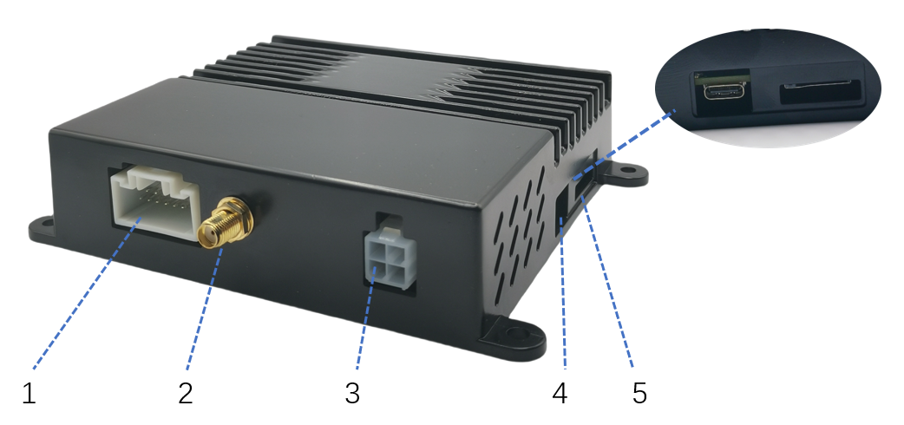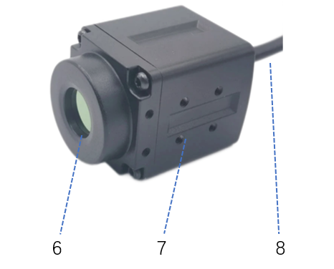
ECU thermal camera

- Controller data input and output interface
- GPS antenna
- ECU power interface
- Remote control receiver interface, TTL data output, TF card slot (without recording function)
- High strength protection window, effective protection of the lens
- Three alternative mounting positions for multiple situations.
- Camera and cable docking waterproof interface

Accessories and connections
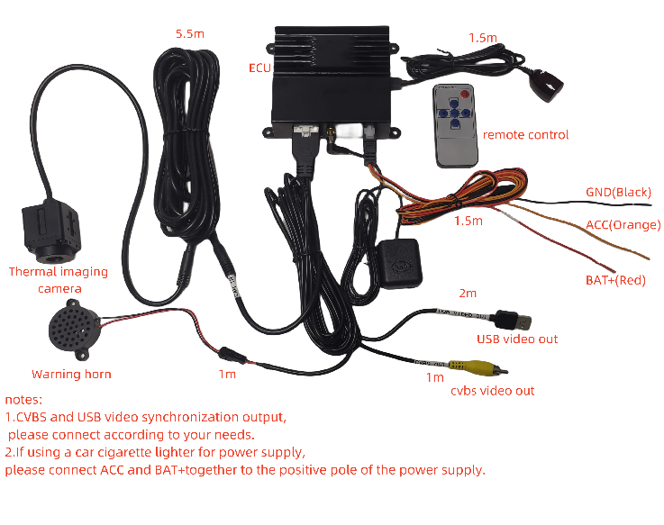
NOTE:The standard product does not include a monitor. If needed, you can purchase a car-specific monitor with CVBS input. It is recommended to choose a 5-10 inch IPS high brightness screen to achieve the best performance. You can also choose our debugged monitor.

ISTALLATION
STATEMENT:This product is so precise that the installation has a very big impact on the use, please go to the Company's designated service points or professional auto repair store to install.

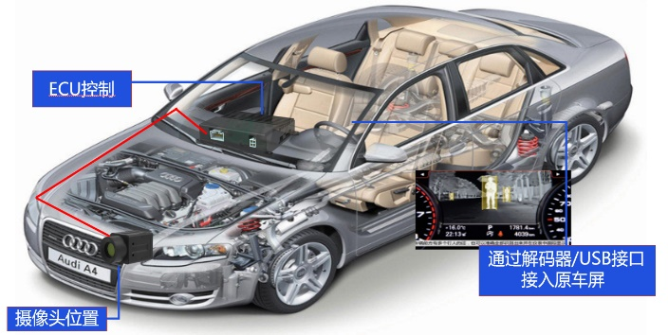
Step 1: build the system structure
Access to the original screen through the decoder/USB interface

Camera position
ECU control
- Mount the imager behind the car's center mesh.
- Route the wiring harness through the engine compartment to the passenger compartment console.
- Choose video output according to your actual needs.
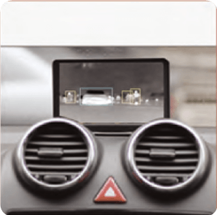
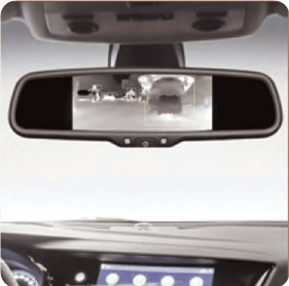
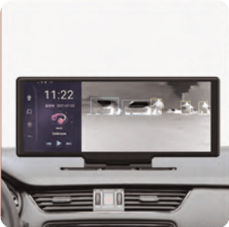
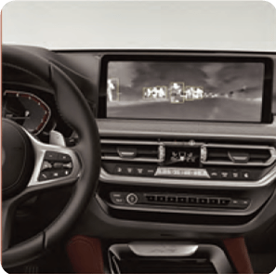
Original Screen Retrofit Screen Rearview Mirror Screen Android Screen
Step 2: position the camera

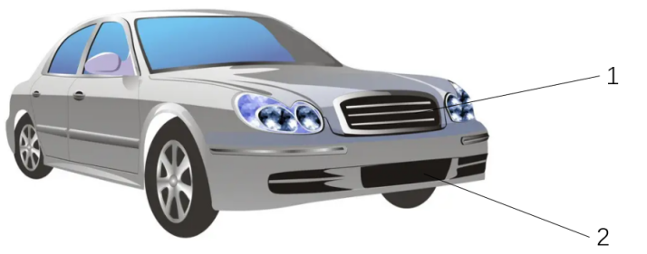

- The camera should be installed inside the front bumper center mesh due to the impenetrability of far-infrared thermal radiation to glass.
- The preferred installation position is in the upper part of the front bumper, zone 1.
- The camera can also be installed zone 2, the lower part of the front bumper when the air inlet in zone 1 of your car is too small (horizontal angle headroom is less than 15mm up and down and left and right) for infrared entry or completely closed.
- This installation method is applicable to all passenger cars, commercial vehicles and other models.
- The camera is not required to be installed in the middle position. Please install on the upper middle position according to the specific model.

Step 3: Camera installation (versatile bracket, U-shaped bracket)

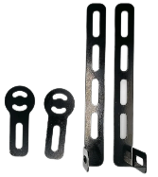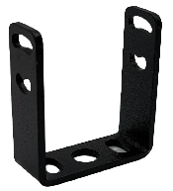

- The bracket is universal and can be easily installed on a variety of models.
- By bending and cutting, the bracket has various installation models and can be adjusted after mounting.
- A variety of mounting screws and clips accessories / car-specific mounting accessories is provided. Please fix the camera appropriately according to the materials and structures of the center mesh.
- The effect diagram.
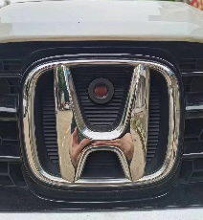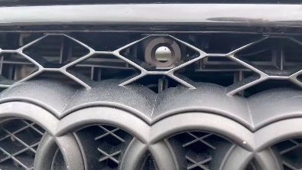

Step 4: adjust the camera angle
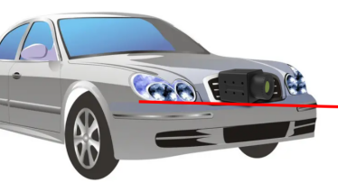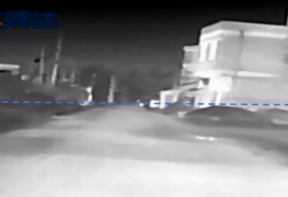

- The camera should be parallel to the direction of the car and the screen should be kept vertical (installed horizontally).
- The road in the distance is shown about 1:1 with the sky on the screen.
- After the commissioning, the insurance carrier/center grille should be restored to its original place.

Step 5: arrange the camera wiring harness

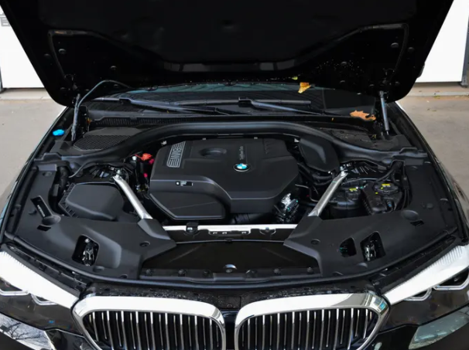

- Generally, camera wiring harness should be arranged through one side of the engine compartment then led from under the A pillar into the cab.
- wiring harness can be leaded to the cab in all models.
- All wiring harness provided are car-dedicated, thermostable and cold-resistant, BLXY and double layer shielding.
- wiring harness should be arranged away from the engine case and are suggested to be parallel and tied to the original wiring harness of cars.

Step 6: install ACC Relay

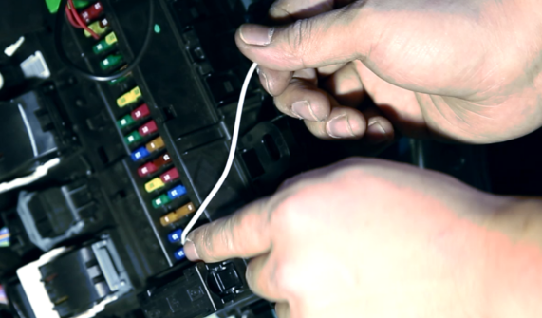

- The car-dedicated relay is provided with a small-size fuss.
- Usually the fuse box is beside the A pillars or under the steering wheel.
- Attach AC12V to car standing electricity and ACC to ACC relay interface. The ground wire should be grounded.
- The reserved DC5V output in power wiring harness could be ignored in installation.
- The system is suggested to be installed in the cooperative installation service point or professional auto repair shop.
- The device automatically shuts down without causing loss of battery power after the ACC power off or when the car is locked

Step 7: install GPS

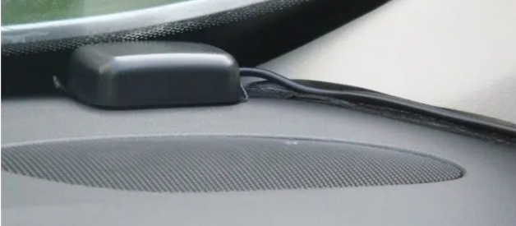

- Place GPS antenna under the A pillar and front glass or inside the A pillar.

Step 8: connect monitor

8.1 extensional monitor
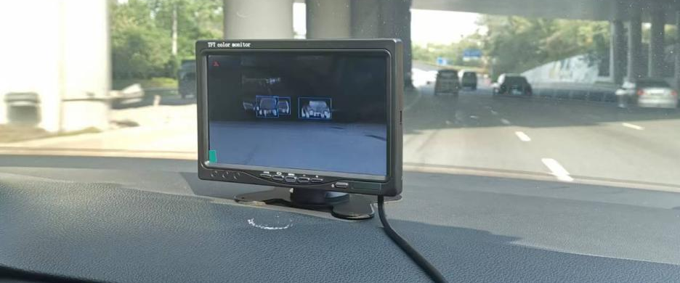
- A 7-inch IPS 1024 * 600 （or 5-inch）resolution high-definition monitor is suggested
- Refer to step 6 for monitor power connection from ACC.
- Please connect the CVBS input plummer of the night vision ECU to the display input.
- The monitor can be glued to the front lid or suctioned to the front glass as desired.

9.2 original screen/Android screen

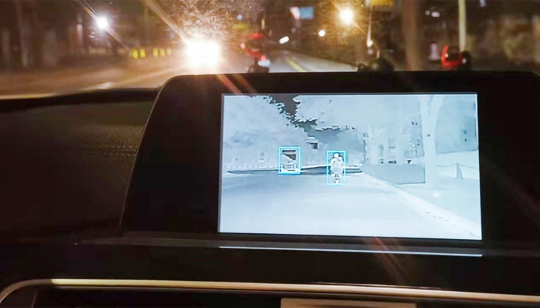
- At present, the device supports CVBS and USB output. If your original screen is an Android one and supports the installation of third-party Android APP, you can find the corresponding dealer to obtain a special APP. The USB video output in ECU output wiring harness should be accessed to the car USB data port. Open the APP when using the system.
- If your original screen cannot install APP, please contact your dealer to buy a special decoder and input it to the original screen in a lossless way.
- The main functions of this product are upgrading gradually, so please focus on the actual controller functions.

Step 10: turn on the system
- After completing the above steps, hide the relevant wiring harness.
- The system automatically run when ACC is on.
- First run requires 18 seconds of boot-up time (including thermal imaging camera warm-up).
- Wait until the thermal images appear on the screen.
Normal power-on pictures:
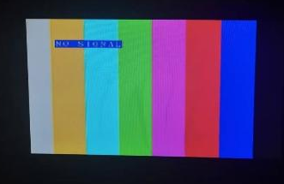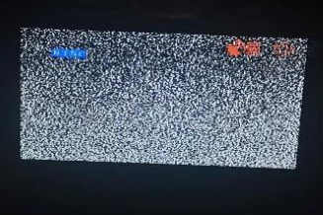
a.System booting in b.camera booting in
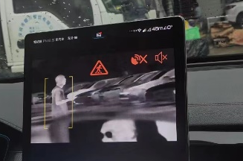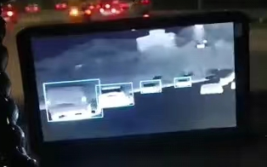

c. Sound alarm off when GPS is
Searching or the car stops

d. the GPS signal is strong and the vehicle speed exceeds 30KM/H

EARLY ALARM
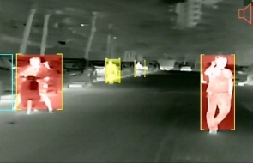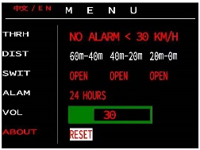
This system comes with pedestrian and vehicle recognition, pedestrian distance measurement, and intelligent warning algorithms. Through dynamic analysis of linked vehicles and comprehensive artificial intelligence algorithms, it outputs visual and audio warnings based on collision risk levels and parameter settings. When the recognized pedestrian meets the warning conditions, the sound warning function will automatically start.
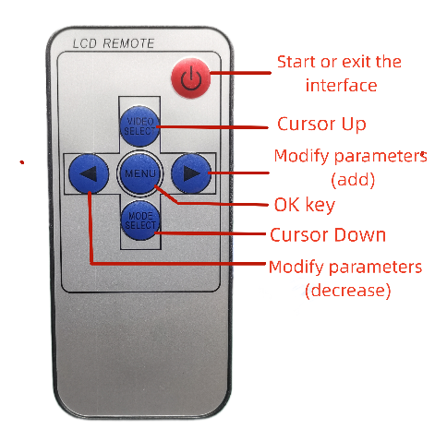
Warning vehicle speed: When the vehicle speed is below the set value, the horn warning will not be activated (GPS is required). If set to 0, it is in sentinel mode. The system detects a person and issues a horn alarm within the warning distance.
Pedestrian warning distance: Voice alarms for different distances can be activated according to actual needs.
Warning time: Voice alarm can be activated at night or all day.
Volume: Set the alert volume.
Restore default: The default warning speed is 30km/h, all 3 warning distances are on, the warning time is all day, and the volume is 30

UPGRADE
- Please copy the firmware file (obtained from the official website or dealer) to the root directory of TF card, insert the card into the slot, turn on the power, and the machine will be upgraded automatically after starting.
- Please do not power off or do other operations during the upgrade process.
- The system will restart automatically after the upgrade is completed
- After the upgrade is completed, please delete the upgrade file in the TF card or remove the TF card, otherwise, the IF card with the upgrade program will repeat the upgrade after each boot.

MAIN PARAMETERS
Camera | Type of detector | Vanadium oxide non-cooling infrared focus plane detector
Camera | Resolution | 256×192 / 384*288
Camera | Lens | Focal length:1.0mm FOV:18°* 13°(256×192)
Camera | Automatic defrost | Yes
Camera | Pixel spacing | 12μm
Camera | Image display | automatic shutter refresh,white hot,≤25Hz
Camera | Protection level | IP67
Camera | Operating temperature | -30℃ - 70℃
Camera | Size | ≤49*34*34(L×W×H mm)
Controller | operating voltage | DC9-36V
Controller | Power consumption | ≤5W（heating≤7W）
Controller | Video output and other interface | CVBS、USB、CAN、UART
Controller | Boot time | ≤18S
Controller | Automatic identification type | Pedestrians, bicycles, two-wheeled electric vehicles, tricycles, motorcycles
Controller | Automatic identification distance | ≤80-100m(256*192)
Controller | Identification efficiency | Identification rate≥95 %，Real-time≥21 FPS
Controller | Early warning method | screen and sound warning
Controller | Operating temperature | -30℃ - 70℃
Controller | Size | ≤110*100*25 (L×W×H mm)

PRODUCT INTERFACE DEFINITIION
INTERFACE | NUMBER | SIGNAL | SIGNAL DECRIPTIONS
Host power interface  （4P Wire Harness） | 1 | NULL
Host power interface  （4P Wire Harness） | 2 | Red BAT+ | Connect the positive terminal of the battery (car standing electricity)
Host power interface  （4P Wire Harness） | 3 | Orange ACC | Connect the ACC switch of the power take-off box
Host power interface  （4P Wire Harness） | 4 | Black GND | Connect the negative terminal of the battery
Host external interface（16PWire Harness） | 1-2 | SPK+、SPK- | 2P warning speaker interface
Host external interface（16PWire Harness） | 3-6 | Video Input | Waterproof interface, connect to thermal imaging camera
Host external interface（16PWire Harness） | 7 | RS232-TXD | reserved
Host external interface（16PWire Harness） | 9 | RS232-RXD | reserved
Host external interface（16PWire Harness） | 8、10 | CAN_L、CAN_H | reserved
Host external interface（16PWire Harness） | 11 | Black GND | reserved
Host external interface（16PWire Harness） | 11-14 | USB Video Output | UVC signal output, connect to smart devices (cell phones, tablets, computers, Android screens)
Host external interface（16PWire Harness） | 15-16 | CVBS Video Output | Connect to monitor or special decoder

PS：
- CVBS and USB video output synchronized output by default
- Camera and host connection cable length 5.5 meters (including extension cable)
- USB video output cable is 2 meters long
- CVBS video output cable is 1 meter long
Troubleshooting Common Faults

Faults | Cause | Solution
Power-on abnormalities | Relay | Detect the contact
Power-on abnormalities | Controller connection interface | Check/Replace
Power-on abnormalities | ACC | Check the fuse box
Image abnormalities | Controller | Check/repair the controller
Image abnormalities | Camera | Check/repair the camera
Image abnormalities | APP | Reload the APP
Image abnormalities | Circuit | Check the circuit

